MATERIALS:
4 skeins Lion Brand Rewind in Olive You
Size US J/10 (6mm) crochet hook
Stitch marker
Tapestry needle
FINISHED SIZE:
Diameter: 15”/38cm
Strap length: 15”/38cm
GAUGE:
13 sts + 14 rows = 4”/10cm in single crochet
ABBREVIATIONS:
*All Two of Wands patterns are written in standard US terms
Ch – chain
Rep – repeat
Sc – single crochet
Sk – skip
Sl st – slip stitch
St(s) – stitch(es)
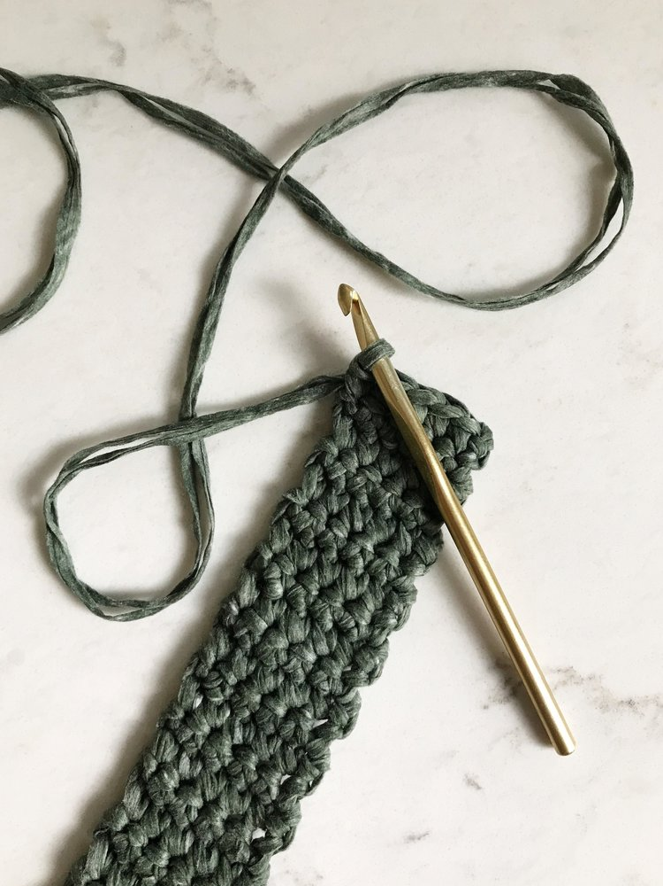
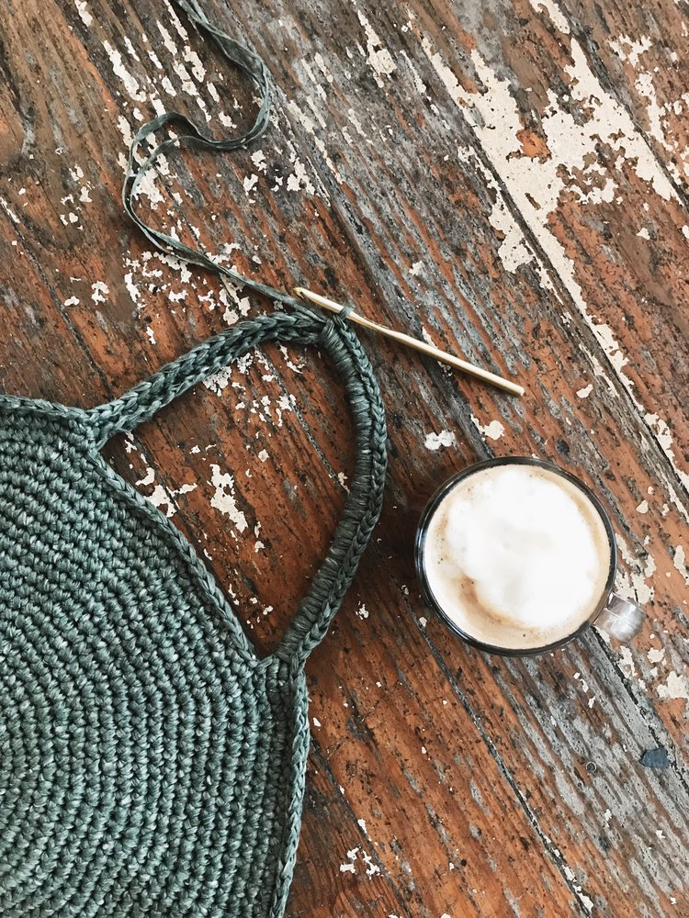
Note: Front and back of bag are worked in un-joined spiral rounds. Use a stitch marker to keep track of start of round. Outer edge of bag is worked separately and crocheted on to front and back. Two strands of yarn are held together throughout. Increases are staggered to keep edges round.
Front and Back (make 2):
With two strands held together, begin with a magic loop.
Round 1: Ch 1, and work 6 sc into the loop. Do not join, place marker for beginning of round. Pull on the tail end to close magic loop. (6 sts)
Work in spiral, un-joined rounds, moving the marker up each round to mark the beginning of the round.
Round 2: 2 sc in each st. (12 sts)
Round 3: *2 sc in next st, sc in next st, rep from * to end of round. (18 sts)
Round 4: Sc in next st, 2 sc in next st, *sc in next 2 sts, 2 sc in next st, rep from * to last st, sc in last st. (24 sts)
Round 5: *2 sc in next st, sc in next 3 sts, rep from * to end of round. (30 sts)
Round 6: Sc in next 2 sts, 2 sc in next st, *sc in next 4 sts, 2 sc in next st, rep from * to last 2 sts, sc in last 2 sts. (36 sts)
Round 7: *2 sc in next st, sc in next 5 sts, rep from * to end of round. (42 sts)
Round 8: Sc in next 3 sts, 2 sc in next st, *sc in next 6 sts, 2 sc in next st, rep from * to last 3 sts, sc in last 3 sts. (48 sts)
Round 9: *2 sc in next st, sc in next 7 sts, rep from * to end of round. (54 sts)
Round 10: Sc in next 4 sts, 2 sc in next st, *sc in next 8 sts, 2 sc in next st, rep from * to last 4 sts, sc in last 4 sts. (60 sts)

Round 11: *2 sc in next st, sc in next 9 sts, rep from * to end of round. (66 sts)
Round 12: Sc in next 5 sts, 2 sc in next st, *sc in next 10 sts, 2 sc in next st, rep from * to last 5 sts, sc in last 5 sts. (72 sts)
Round 13: *2 sc in next st, sc in next 11 sts, rep from * to end of round. (78 sts)
Round 14: Sc in next 6 sts, 2 sc in next st, *sc in next 12 sts, 2 sc in next st, rep from * to last 6 sts, sc in last 6 sts. (84 sts)
Round 15: *2 sc in next st, sc in next 13 sts, rep from * to end of round. (90 sts)
Round 16: Sc in next 7 sts, 2 sc in next st, *sc in next 14 sts, 2 sc in next st, rep from * to last 7 sts, sc in last 7 sts. (96 sts)
Round 17: *2 sc in next st, sc in next 15 sts, rep from * to end of round. (102 sts)
Round 18: Sc in next 8 sts, 2 sc in next st, *sc in next 16 sts, 2 sc in next st, rep from * to last 8 sts, sc in last 8 sts. (108 sts)
Round 19: *2 sc in next st, sc in next 17 sts, rep from * to end of round. (114 sts)
Round 20: Sc in next 9 sts, 2 sc in next st, *sc in next 18 sts, 2 sc in next st, rep from * to last 9 sts, sc in last 9 sts. (120 sts)
Round 21: *2 sc in next st, sc in next 19 sts, rep from * to end of round. (126 sts)
Begin handle shaping:
Round 22: Sc in next 10 sts, 2 sc in next st, (sc in next 20 sts, 2 sc in next st) 4 times, sc 13, ch 32, sk 17, sc in last st. (114 sts on bag, 32 ch handle)
Round 23: *2 sc in next st, sc in next 21 sts, rep from * to 3 sts before ch begins, 2 sc in next st, sc in next 2 sts, sc in each ch, sc in last st. (120 sts on bag, 32 sts on handle)
Round 24: Sc in next 11 sts, 2 sc in next st, (sc in next 22 sts, 2 sc in next st) 4 times, sc remaining 15 sts of bag, sc in each st of handle, sc in last st. (125 sts on bag, 32 sts on handle)
Sl st in 1st st of next round. Cut yarn.
Outer Edge Band:
With two strands of yarn held together, ch 6.
Row 1: Starting in 2nd ch from hook, sc across row. (5 sts)
Row 2: Ch 1, sc across row.
Rep row 2 until work measures 30”/76cm.
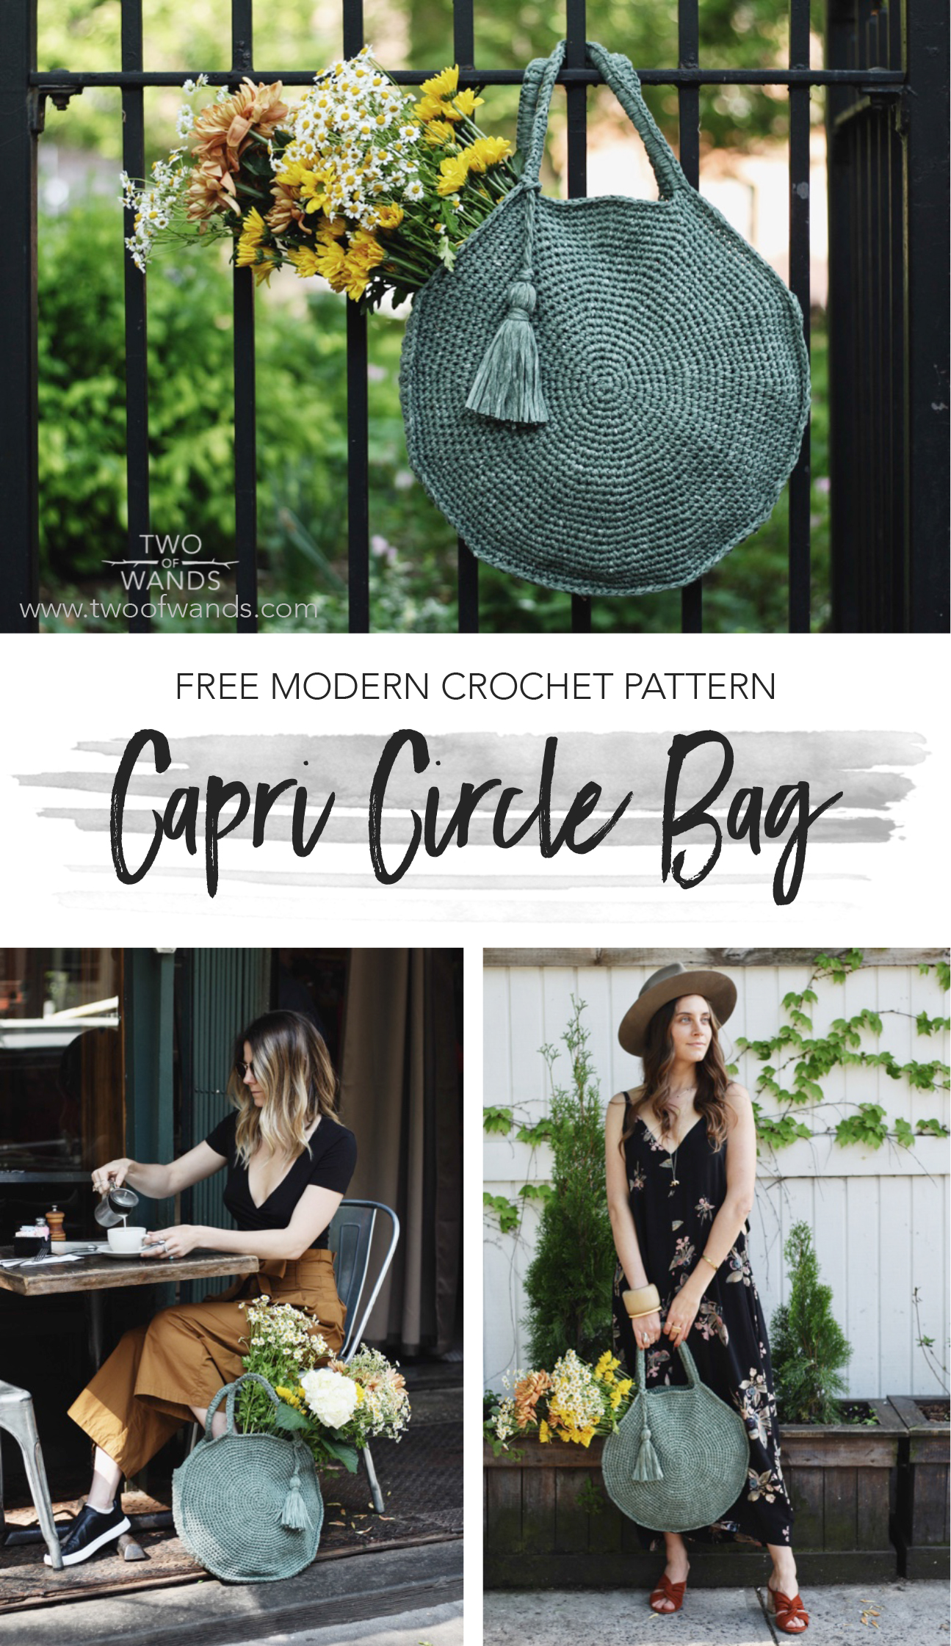
Construction:
Place outer edge band around one circle so that there is even space on either side of handle. With right side of circle facing up, single crochet the edge of the circle together with the band all the way around. When you reach the end of the band, sl st up remaining side of circle to handle, then sc tightly around the entire handle (rather than into the sts) approx. 56 times, then sl st down other side of circle to beginning of outer edge band. Rep on other circle to attach band and complete second handle.
Tassel:
Cut four 18”/46cm lengths, two 12”/30cm lengths, and thirty 14”/36cm lengths of yarn. Tie the four 18”/46cm lengths together at one end, separate them into 2 groups of 2 strands, twist each group counter-clockwise, then twist the two groups together clockwise. Tie together at bottom end, then tie the ends together, trimming off the knotted ends. Fold the thirty 14”/36cm lengths of yarn over the knot join of the cord, then tie the cord in an overhand knot to secure it to the folded bundle. Tie crosswise around the folded bundle approx. 1”/2.5cm below top of fold with remaining 12”/30cm lengths. Wrap the tails of the ties around and around the bundle and then thread them inside and down the middle of the bundle with a tapestry needle. Trim tassel to desired length. Loop tassel through its cord to attach it to one of the bag handles.
Purchase the printable, ad-free pattern here.
Purchase the kit from Lion Brand Yarn here.
Don't forget to share your projects made using Two of Wands patterns on Instagram with the hashtag #crewofwands so your post will get featured on my site and you'll be in the running for monthly pattern giveaways!
Check out the #crewofwands community page here.
The pattern and photographs of this design are the property of Two of Wands. This pattern and design are subject to copyright, and are for personal, non-commercial use only. You may not distribute or sell this pattern or any items created using the directions in this pattern without consent. Please visit my policies for more information.

